**SEVERN VALLEY COUNTRY PARK**

The Green Flag award winning Severn Valley Country Park is the perfect day out for all the family. Set in the peaceful, scenic valley of the River Severn, the park provides 126 acres of beautiful countryside and wonderful views which spans both sides of the longest river in the country. The woodlands, ponds and meadows of the park around found in 2 separate sites located at Alveley and Highley. Visitors can explore way-marked walking routes and see rare wildlife that has been lost from the wider countryside. An action-packed events programme including guided walks, activities for kids, outdoor theatre and seasonal self-guided trails ensures there is always something exciting happening.

**HISTORY OF SEVERN VALLEY COUNTRY PARK**

Now an oasis of peace and tranquillity, this part of the Severn Valley used to be a centre of industry. Sandstone quarried from the area was used to build part of Worcester Cathedral. Coal mining started in Highley in 1878. Production was switched to Alveley in 1936 and the Miners Bridge was built across the Severn. At its peak the mine employed 1000 men and produced 300,000 tonnes of coal a year. It shut down in 1969 and the spoil heaps and mine site lay derelict until 1986 when the project to create Severn Valley Country Park was instigated. The project saw the reclamation of land, installation of drainage ditches, re-grading of the spoil heaps and planting of trees leading to the opening of the park in 1992.

**WILDLIFE HABITATS**

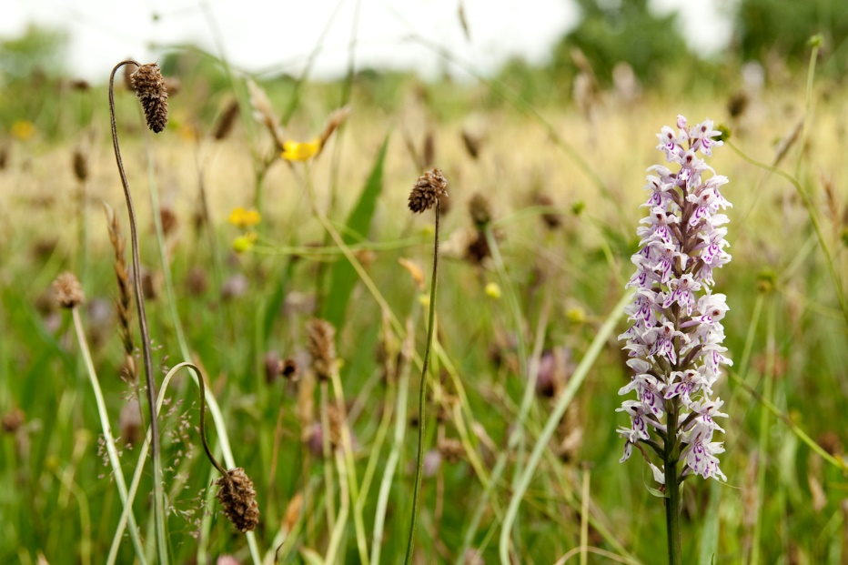

Severn Valley Country Park is a great mix of valuable habitats. Hall Close Coppice is semi-natural ancient woodland that is alive with bird song and wildflowers each spring. It is managed by coppicing small areas of hazel and alder and allowing them to re-grow. The spring pieces are species-rich grassland. A walk through this area will reveal thousands of orchids and other plants including adder’s tongue fern and yellow rattle. An easy access nature trail takes in a duck pond and leads to a fully accessible bird hide overlooking a wetland and reed bed with the chance of seeing a good range of birds. Elfin pool is a spring-fed pond that is a popular location for pond-dipping. The riverside meadows are a great place to see invertebrates including the rare club-tailed dragonfly. Visitors can also join the riverside footpaths and experience longer walking routes taking in the wonderful scenery.

The Severn Valley Railway goes through the middle of the park and the steam trains are a popular feature for visitors. Throughout the spring and summer months, thousands of school children visit the park and some groups choose to arrive in style on a steam train. It is also possible to combine a walk with a return ride on a steam train, alighting at the country park halt.

**THINGS TO SEE AND DO**

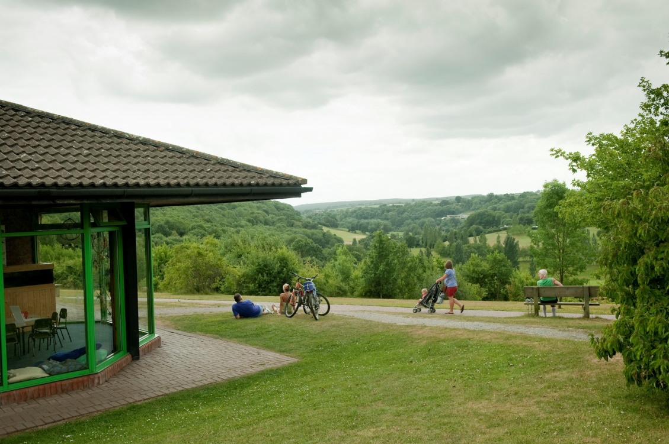

**Severn Valley Country Park has a full range of facilities for visitors to enjoy. A map of the park can be downloaded** [here](http://www.shropshiresgreatoutdoors.co.uk/wp-content/uploads/2015/12/park_leaflet.pdf)

* Visitor centre and cafe

The park boasts a fantastic visitor centre with plenty of information about the history and wildlife of the area. There is also a kid’s corner with activities for our younger visitors.

In the cafe you can sample a piece of home-made cake and a cup of tea whilst admiring the beautiful view. Our cafe menu offers a selection of snacks including made-to-order sandwiches, soup and jacket potatoes.

* Natural Play area with climbing frame, basket swing and a rope bridge.
* Request stop for the Severn Valley Railway

When traveling on this fabulous heritage railway line, if you ask the guard for the ‘Country Park Halt’ the train will make a stop at the park. It is possible to board a train here also. If you stand on the platform, with your arm outstretched an approaching train will stop at the platform. More details about the Severn Valley Railway can be found [here](http://www.svr.co.uk/Default.aspx).

* Picnic areas

Picnic tables are located outside the visitor centre, near the children’s play area, adjacent to Country Park Halt and in the river meadows.

* Easy Access Trail

This trail is located through a gate situated in the out-of-hours car park. The trail has been recently improved to ensure the flat path is suitable for wheelchairs and pushchairs. The trail loops around a beautiful lily pad covered pond.

* Fully accessible bird hide

The bird hide over looks our wetlands. The reeds in the wetlands are cut annually to create the perfect conditions for wading birds such as water rail. Herons are regular visitors as well as moorhens, coots, kingfishers and mallards. Rare sightings include bitterns and otters.

* Permanent orienteering trail with 3 levels of difficulty

The course has been set up by Wrekin Orienteers and maps are available to purchase from the visitor centre for £1.50 each.

* Toilets, including disabled facilities and a baby change units at Alveley and Highley
* Car parking at Alveley and Highley

**Walking, Cycling and Horse Riding at Severn Valley Country Park**

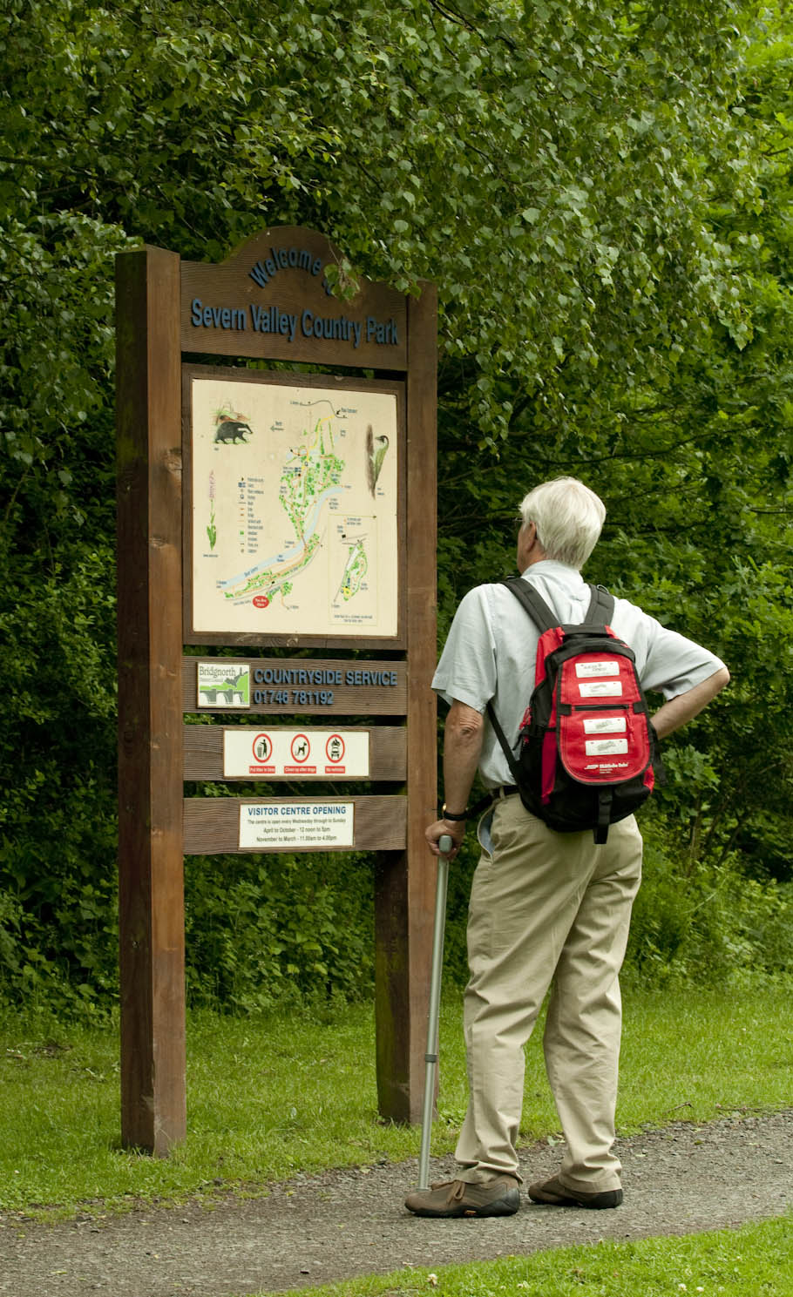

* Explore the site on one of the way-marked walking routes

**The** **Woodland Trail** is a 1-mile circular walk which passes through 3 distinctly different types of woodland. (Follow the green way markers from the visitor centre).

**The Riverside Trail** is a 2-mile trail which takes you along the unspoilt banks of the River Severn through traditional meadows and woodland both ancient and new. (Follow the blue way markers from the visitor centre).

**The Highley Trail** takes you outside the park boundaries to explore the local community of Highley. On this 3.5-mile walk you will discover the world of wild rivers, big views, fantastic wildlife and giant industry. (Follow the ‘Highley Trail’ way markers from the visitor centre). For a map and more information, click [here](http://www.shropshiresgreatoutdoors.co.uk/wp-content/uploads/2016/10/highley-trail-leaflet.pdf).

**A Country Park Geology Trail** takes you on a 1.2-mile circular walk examining the geological highlights of the Severn Valley. The trail was devised by experts from the Abberley and Malvern Hills Geopark and uncovers the story of the park over the past 320 million years. The trail can be downloaded [here](http://geopark.org.uk/pub/wp-content/uploads/2015/06/SVCP-TRAIL-lower-res.pdf).

* Bring your bicycle

**The Mercian Way** (part of route 45 of the National Cycle Network) passes straight through the middle of the park. Running from Bewdley to Bridgnorth and beyond, the route covers rural lane and off road tracks to take visitors into a world of unspoilt riverside, woods and meadows. Riding through the park you have the unique opportunity to cycle in parallel to the vintage steam trains of the Severn Valley Railway. It is the perfect safe, family-friendly, traffic free environment. Click [here](http://www.shropshiresgreatoutdoors.co.uk/cycling/long-distance/mercian-way-national-cycle-network-route-45/) for more information about the Mercian Way.

**The Shropshire Cycleway East: Severn** takes cyclists on a journey from Telford through Ironbridge, Bridgnorth, the country park and on towards Cleobury Mortimer. It takes you through the beautiful landscape of the Severn Valley and passes by the country park. The full Shropshire Cycleway route is a 185 mile route around Shropshire’s border. Click [here](http://www.shropshiresgreatoutdoors.co.uk/cycling/shropshire-cycleway/) for more information about the Shropshire Cycleway.

There is a bike rack located outside the visitor centre, to enable cyclists to enjoy a well-deserved break in our teashop.

* Horse Riding at Severn Valley Country Park

**The Jack Mytton Way** comprises of over 100 miles of rural bridleways and quiet country lanes. The trail passes near to the park at Highley and riders can divert from their trek to enjoy some time with us. Through the park there is a public bridleway and riders are invited to use our other surfaced paths. In 2013, a project undertaken by our volunteers to transform a section of the park into a wild flower meadow included the addition of a new bridleway from our car parking area.

Mounting blocks are located at either end of the Miner’s Bridge for rider’s convenience and horses can be safely tethered in our yard whilst riders visit our teashop and centre. Please ask staff on site for more details.

More details about the Jack Mytton Way can be found [here](http://www.shropshiresgreatoutdoors.co.uk/horse-riding/jack-mytton-way/).

**VOLUNTEERING**

Volunteers at Severn Valley Country Park meet every Tuesday and Thursday. The Tuesday group is full, but places are available on Thursdays.

You can meet like-minded people, learn new skills, make new friends and help improve countryside sites for people and wildlife. Tasks include practical work such as coppicing and woodland management, grassland management as well as wildlife monitoring plus many other activities.

All ages and abilities are welcome. For more information and to register your interest, please telephone 01746 781192.

**EDUCATIONAL ACTIVITIES FOR KIDS**

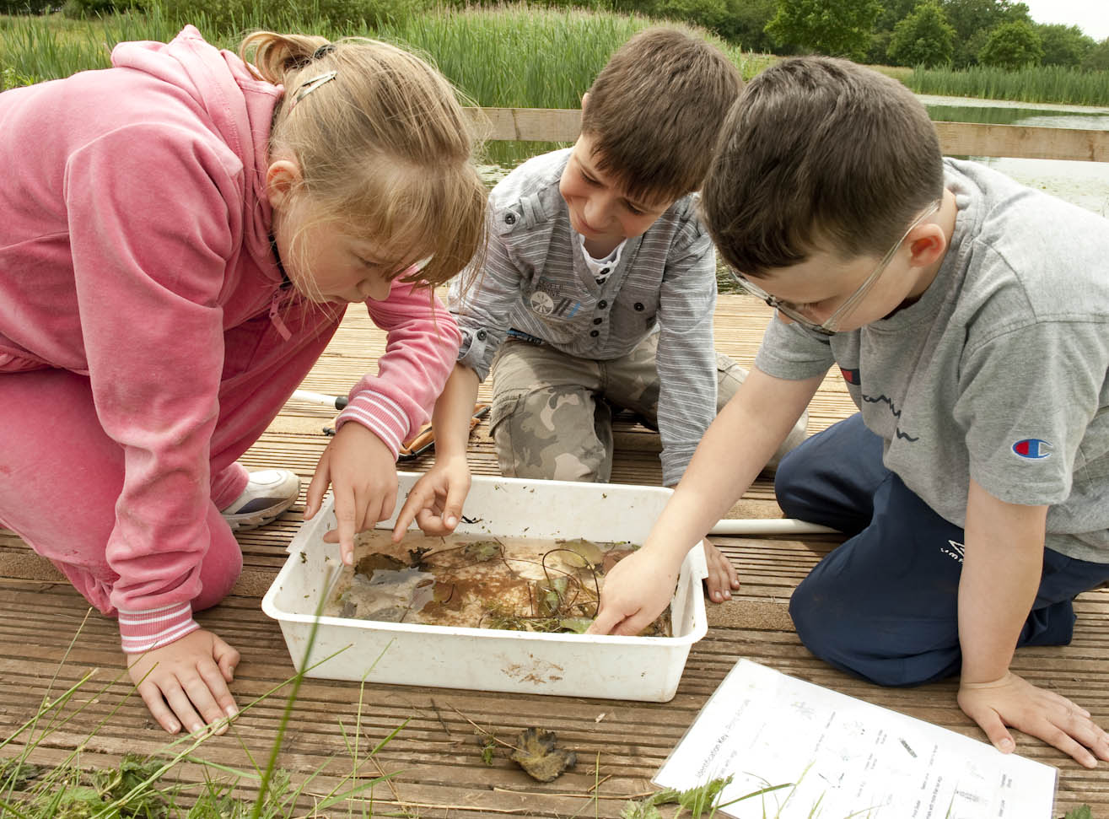

Severn Valley Country Park offer a variety of educational activities that make for a great morning, afternoon or whole day out.

All of the activities provided are delivered by qualified rangers, and have valuable links with the national curriculum in the sciences, geography and history.

Click to find out more about the activities on offer:

[Educational activities for kids - mini-beast hunts](http://www.shropshiresgreatoutdoors.co.uk/wp-content/uploads/2018/09/Mini-Beast-Hunts-sept-2018.pdf)  
[Educational activities for kids - orienteering](http://www.shropshiresgreatoutdoors.co.uk/wp-content/uploads/2018/09/Orienteering-sept-2018.pdf)  
[Educational activities for kids - pond dipping](http://www.shropshiresgreatoutdoors.co.uk/wp-content/uploads/2018/09/educational-activities-for-kids-pond-dipping-sept-2018.pdf)  
[Educational activities for kids - river study](http://www.shropshiresgreatoutdoors.co.uk/wp-content/uploads/2018/09/river-study-sept-2018.pdf)  
[Educational activities for kids - scavenger hunt](http://www.shropshiresgreatoutdoors.co.uk/wp-content/uploads/2018/09/scavenger-hunt-sept-2018.pdf)

The Country Park is happy to welcome school groups from Bridgnorth, Kidderminster, Highley, Alveley, and other towns in the West Midlands, Worcestershire and Shropshire. For more information, call 01746 781 192.